THE COPTIC ICONOGRAPHY

Fr. Tadros Y. Malaty

Icons, indeed, are open books written in a visible, tangible language that simple children might understand, iconographers, theologians and philosophers can study and contemplate deeply, clergymen loaded with excessive congregational responsibilities can enjoy, and in which the spiritual hermit can find comfort.

COPTIC ICONOGRAPHY AND LIFE
Coptic iconography is not merely a branch of arts, but it reveals the richness of the Coptic spirituality. Coptic icons are mirrors that reflect the Coptic Church life as a whole. Icons in general visualizes the church beliefs, hope, concepts of arts, science and philosophy. Coptic icons talk clearly about the communion with heavenly hosts, victory over demons and lifting up the believers’ hearts to heaven.
One of the main characteristics of the School of Alexandria, as the acknowledged leader of the early Coptic Church, believed in the oneness of life. The believer has one life which he / she practices in his / her daily life at home, in the church, at the school, at work and in using all his / her energies, talents and gifts. Through icons we discover this one life.

THE COPTIC CULTURE
The Pharaohs are known for their exceeding religious attitudes, and their longing for the life to come, although they did not know the reality of this life. At the same time, they were interested in science, and they did many scientific marvels which the modern science could not unfold their mysteries till now. Thus, the Egyptians believed in the religious life and in the development and progress in all aspects of knowledge and science. This belief had its effect on the Christian School of Alexandria, which was encyclopedic in its teachings, and presented the whole series of profound sciences beside studying the Holy Scriptures.
The Copts accepted the Christian faith that sanctifies all that is human and develops it, therefore they were genius in iconography, music, architecture, textiles, literature, astronomy etc., and their culture and arts had their effect all over the world.

ART AND WORSHIP
Worship in its essence is the expression of man's response to God's infinite love. Man feels that mere words are unable to express this response, therefore he uses his gifted arts in worship.
Art has been correlated with religion from the beginning of history, so that there had been a strong belief that arts such as, painting, engraving, music, singing, dancing etc., have come into existence as a result of religious beliefs.
In Early Christian times, Copts were involved in the religious life, so that many thousands preferred to live in the wilderness longing for the angelic life. To those who remained in the cities and countries, the Christian faith penetrated into their daily life, even in their eating, drinking, literature and arts. There is evidence that Christian symbols and images were inscribed on their rings, painted on their walls, doors, cups, plates, chairs etc. As an example, at the Coptic Museum in Cairo, there is a Coptic ivory comb from the fifth century. On one side, Lazarus appears in the shape of an Egyptian mummy, while Christ bearing a cross instead of a wand, appears on the other side. Beside it, there is another representation, of the "healing of the blind man". Also on the other side of the comb, there is a mounted Coptic Saint enclosed irrationally within a wreath, supported by angels.
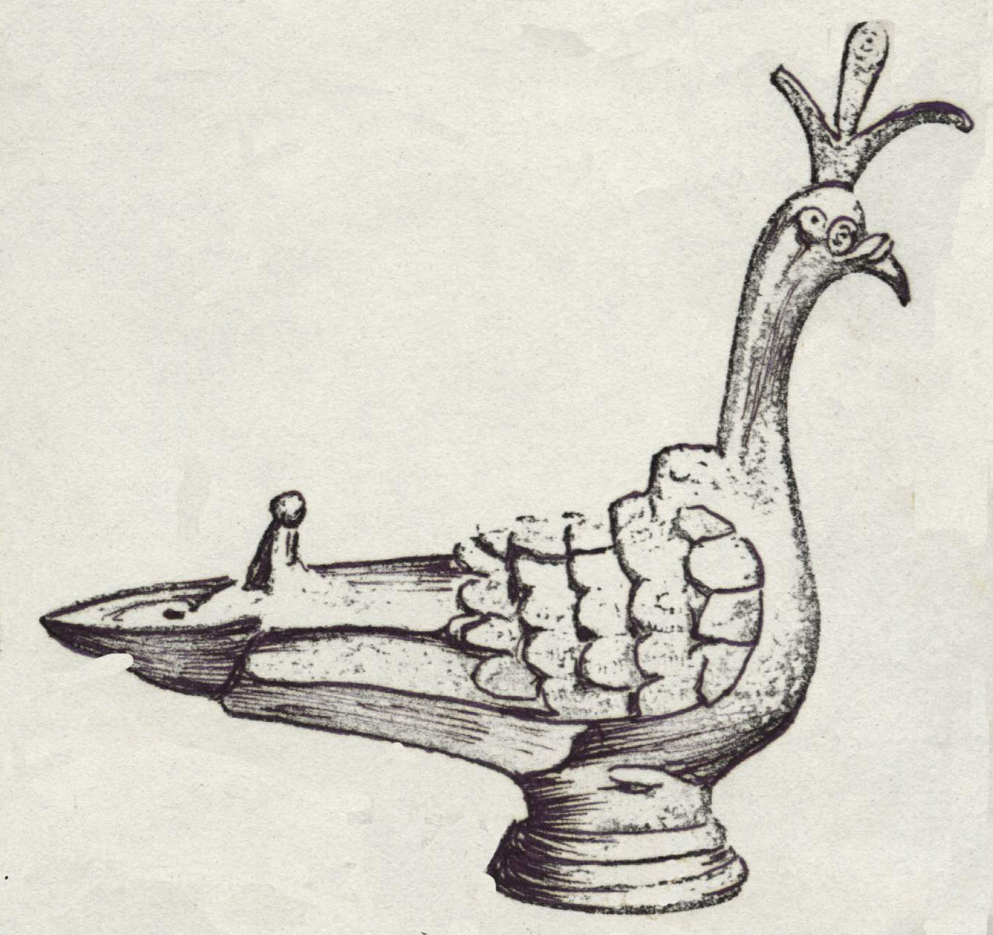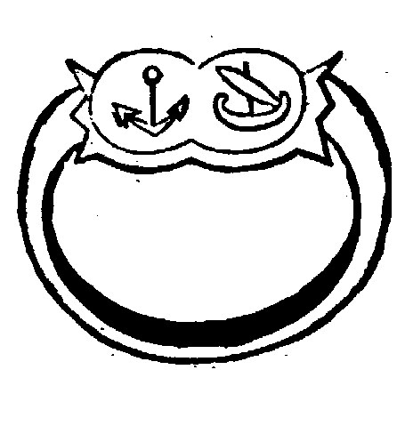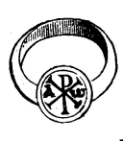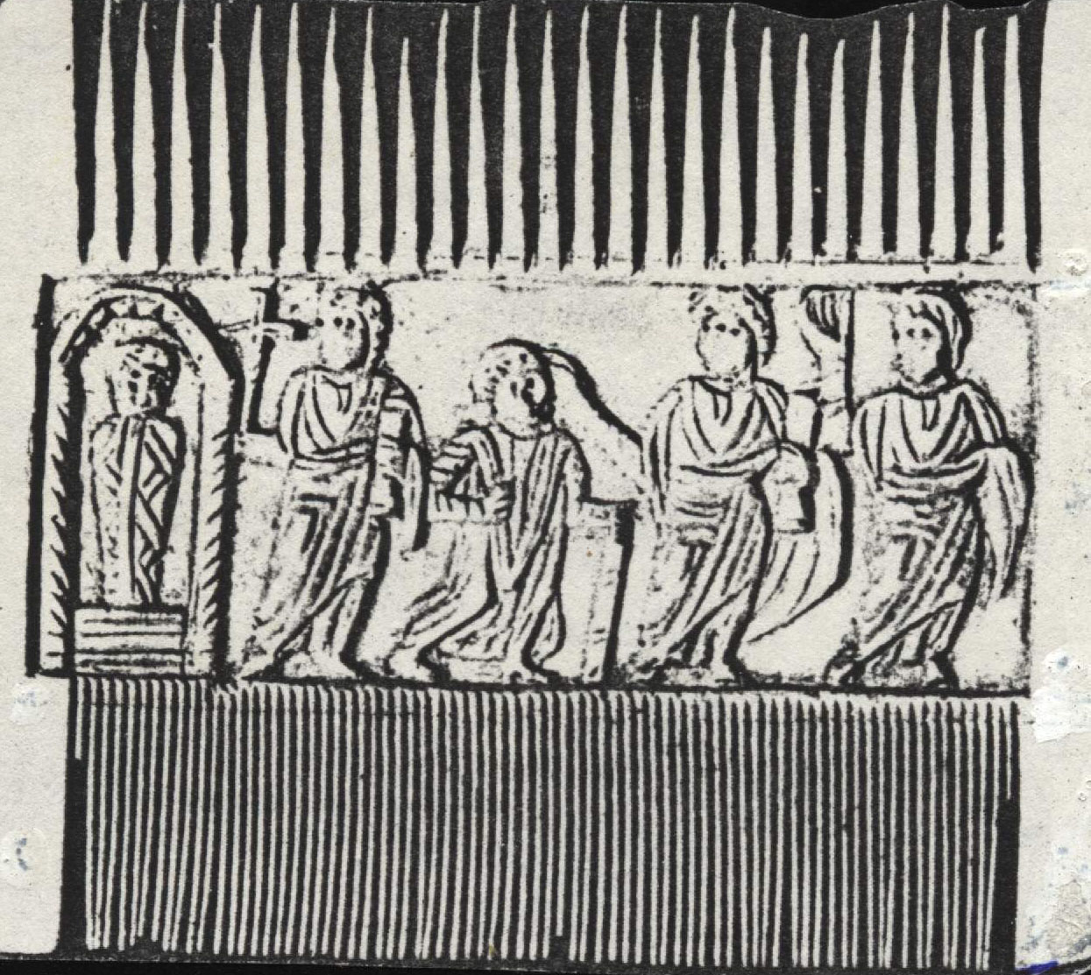

SANCTIFYING ARTS
It is man's desire to offer his life and devote all his culture to express his deep and unspeakable love to God. At the same time, it is God's beneficence that He longs to sanctify man's being, life and culture as a sign of God's high sight to man and his life. God loves man as a whole, He accepts his soul as His dwelling place and does not despise his body and human culture, for these both can be sanctified by the Holy Spirit to act spiritually as instruments of righteousness, for the edification of God's Church on behalf of the heavenly kingdom.

THE PROBLEM OF THE COPTIC ART
No art has been subject to so many disputes as the Coptic Art.
The archeologist Strzugowski hypothesizes that it is just a local continuation of the Hellenistic art. Maspero and Gaet look on the Coptic Art as an offshoot of the Byzantine Art, and Elbera knew it as an authentic national Egyptian art.
This confusion is a natural result of many factors, as follows:
1. Egyptian soil was ruled successively by the Greeks, Romans, and the Byzantines etc., who had cultures and arts of their own. These rulers had their own districts inside the great cities of Egypt, where they left monuments, which are now mixed with the national ones.
2. The present Coptic monuments, however many they are, do not represent the true quality of the Coptic Art, for the most prized and valuable pieces were ruined in unceasing waves of persecution, as the Arabic historian Almakrizi describes. To this effect Klaus Wessel says, “At the height of the medieval period, Arab writers describe magnificent paintings; those of the shrine of St. Menas, for example, were especially famed, but little survives... However to quote S. Der Nersessian, “But even in important centers like Bawit in Upper Egypt or Saqqara in Lower Egypt, the large churches are completely destroyed and the paints which covered their walls are lost forever. Only some of the smaller chapels have retained their decoration, so that, we know Coptic paintings from inferior examples.” We can therefore only get a rough picture of what once was found in abundance, in the churches and monasteries.
A. Hamilton says, “Alexandria, a great and flourishing city, had long before exercised a powerful sway and the formation of Christian art, and must have had numerous churches of great size and beauty. All have disappeared... Egypt must have had splendid churches, but most of the extant ones are small and of poor materials.”

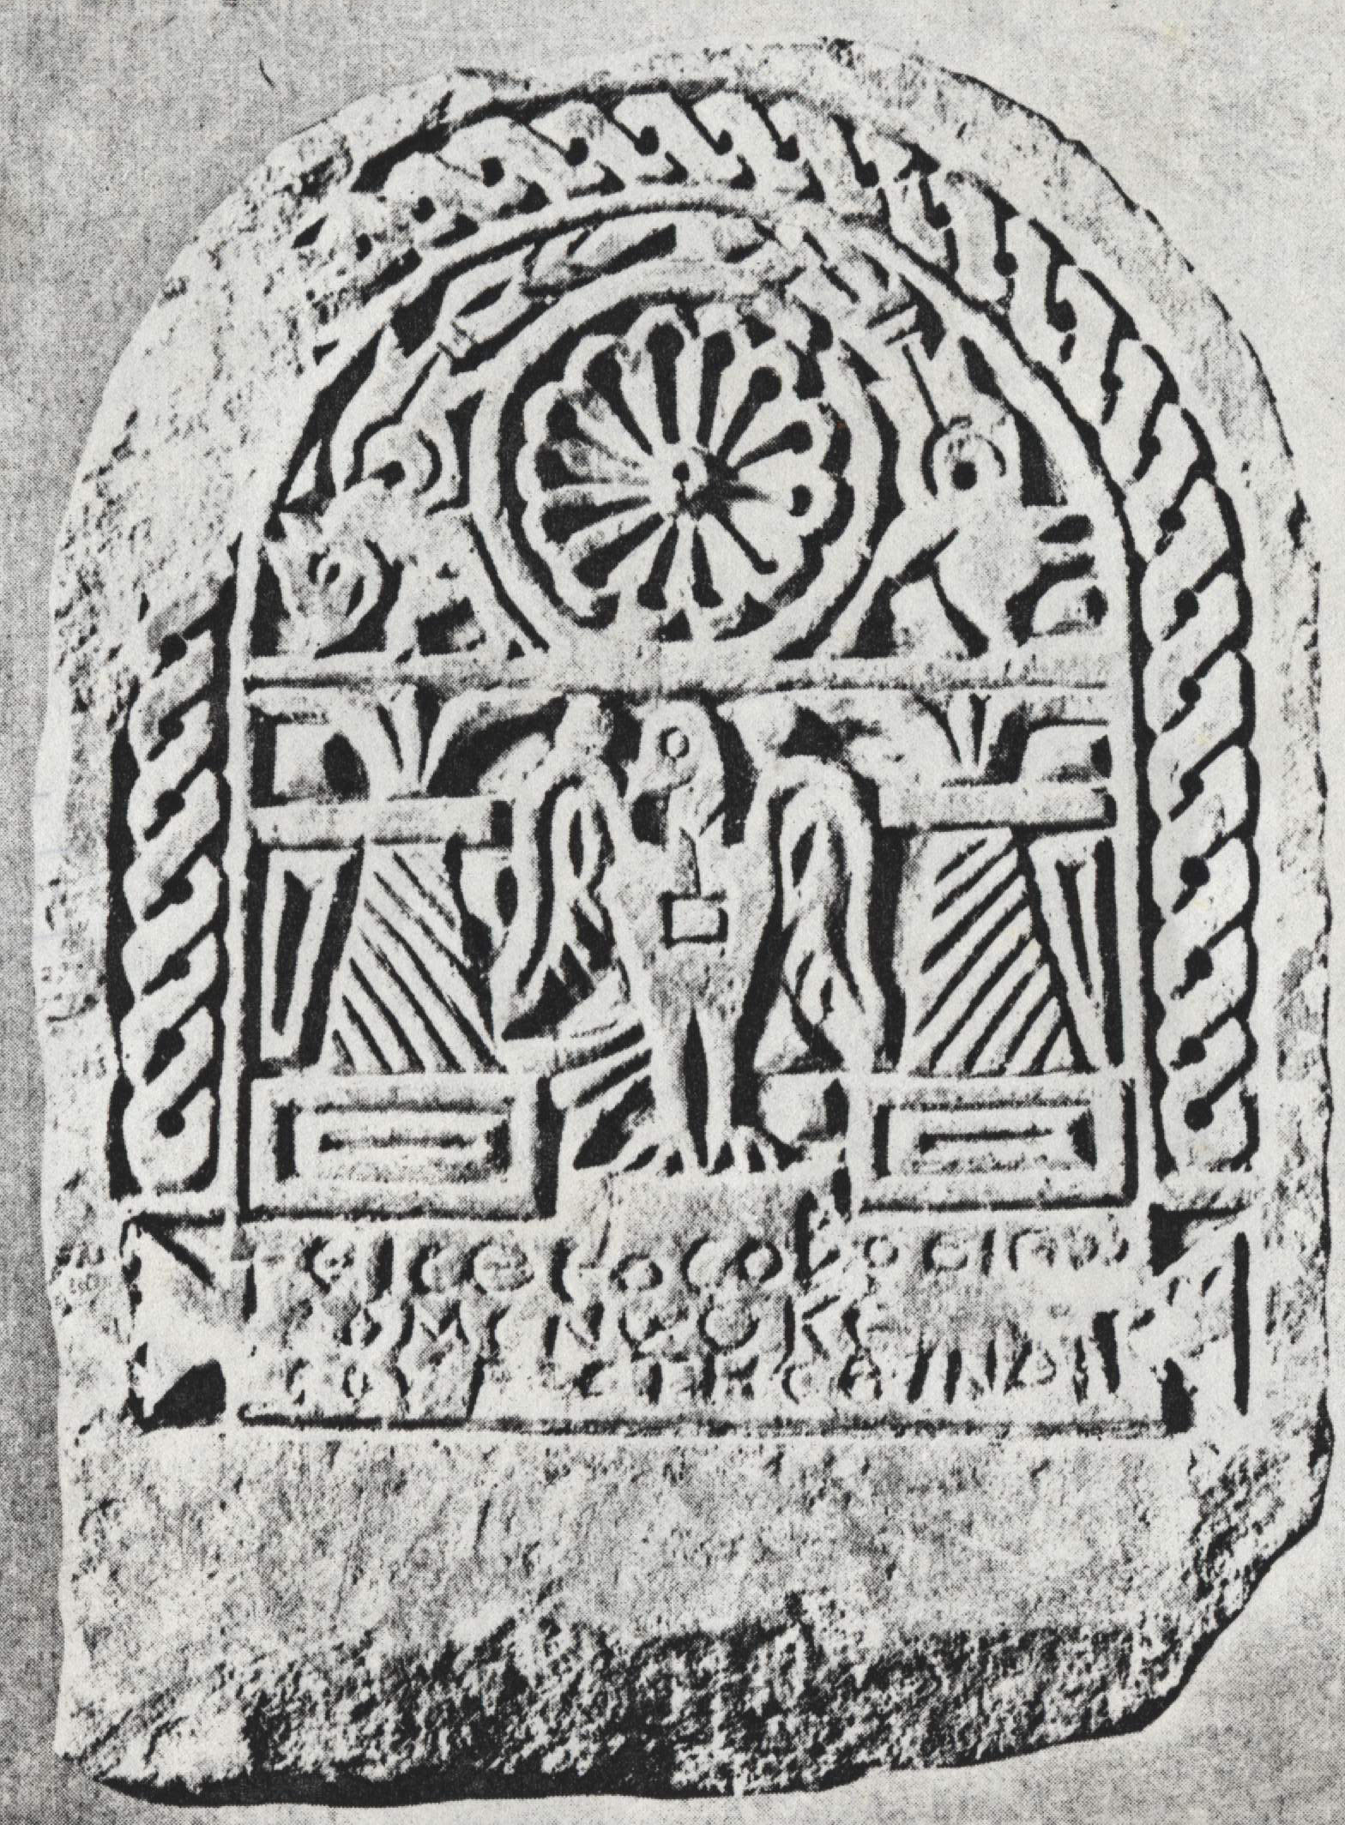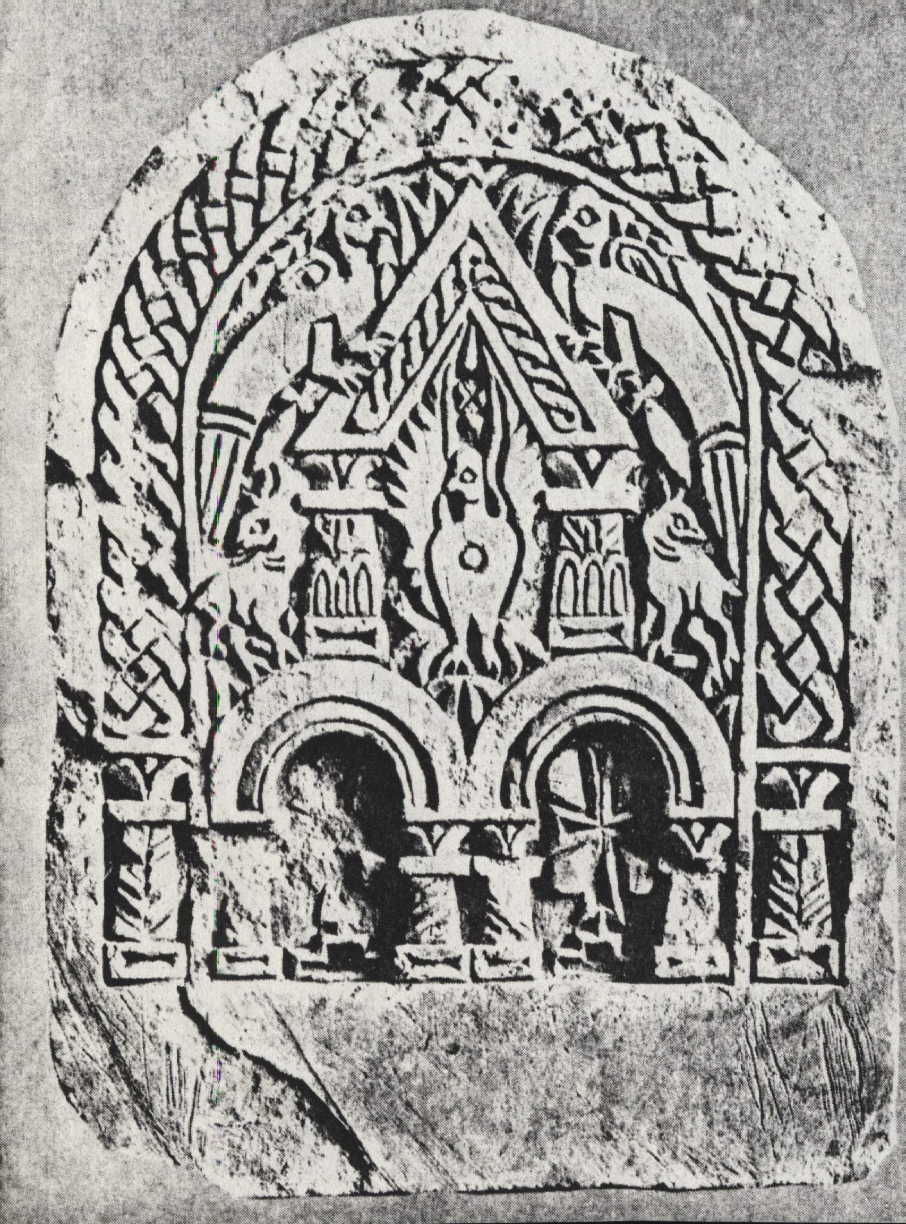

THE COPTIC ART AND THE SCHOOL OF ALEXANDRIA
The School of Alexandria had its effect on the Coptic arts, especial iconography. Alexandria, the cosmopolitan city was chosen as a home of learning, and a "unique center of a brilliant intellectual life, where Egyptian, Greek and Jewish cultures were nourished and gave rise to a new civilization. In such an environment, there was no other alternative but to establish a Christian Institution center to enable the church to face the battle fought by those powerful schools.
The effect of the School of Alexandria on the Coptic iconography can be traced through the following factors:
1. Many deans of the School, such as St. Pantenaeus and St. Clement, didn’t enter in a battle against other schools, but they embraced their cultures and Christianized them. In the second century while Tertullian, the first western theologian declared that there was no friendship between faith and philosophy, nor fellowship between the believer and the philosophy, St. Clement of Alexandria said, "Philosophers are children until they have been made men by Christ." He states that Greek philosophy, like the Law of Moses according to St. Paul, was given as a tutor to bring the Greeks to Christ and as a restraint on sin. Surely this attitude had its effect even in their view concerning arts, specially iconography.
2. The School became the oldest center for sacred sciences in the history of Christianity. In it, the first system of Christian theology was formed and the allegorical method of biblical exegesis was devised. In this context, Dom. D. Rees states, "The most renowned intellectual institution in the early Christian world was undoubtedly the Catechetical School (Didascaleion) of Alexandria, and its primary concern was the study of the Bible, giving its name to an influential tradition of scriptural interpretation. The preoccupation of this school of exegesis was to discover everywhere the spiritual sense underlying the written word of the Scripture." The School which was concerned in discovering the deep and hidden meaning of the Scriptures’ texts, surely was concerned in revealing the inner meanings behind the icons.
3. Ecumenism is a spirit that the School of Alexandria spread not by speaking about the unity of churches all over the world, but by practicing it in many ways:
- The School attracted many foreign students to study theology, especially the interpretation of the Holy Scriptures. Those students later became leaders in their churches.
- The deans of the School were very active outside Egypt, because of their love towards the Catholic Church; they were not looking for any personal prestige nor gaining any political power for their churches. For example Origen traveled to Rome, Caesarea, Arabia, Tyre, etc.
- The Alexandrian theologians were leaders and pioneers in the Ecumenical Councils.
- The Coptic manuscripts are proof that the Copts translated almost all the Christian literature existing in the world at that time.
This ecumenical spirit had its effect on respecting and embracing the arts of other nations, without ignoring their own culture. Therefore we remarks that in one icon the iconographer embraces the Greek style together with the Egyptian one. Some monuments of mixed Ancient Egyptian-Greek character are discovered.
In addition to the classical, ancient Egyptian and ancient Egyptian-Greek heritages in Coptic arts, there are also Persian, Byzantine and Syrian influences. The Egyptian master weavers and artists were attracted to Persia in the third century with the rise of the Sassanian kingdom before the founding of Constantinople. When they returned to Egypt, a new Persian reparatory of themes was introduced to Egypt.

THE DEVELOPMENT OF THE COPTIC ART
Scholars give special interest to Coptic textiles more than icons, for the later were exposed more to ruin than the first, and until recently, Coptic textiles were exported to many foreign countries. However, in this section I concentrate on Coptic icons.

1. COPTIC ICONS AND HELLENISM
When Alexandria received Christianity through the Apostle St. Mark, it was ruled by the Roman Empire, and at the same time it was a leading center of the Hellenistic culture in the East. For this reason some scholars hypothesized that the Alexandrian Christians embraced the Hellenistic culture in expressing their feeling towards the new faith. They have proved this opinion by some monuments found in the Hellenistic centers at Alexandria, Fayoum Oases and other districts of the Delta.
Nevertheless, other scholars explain that these monuments do not represent the authentic Egyptian art, and state that the Copts refused the Hellenistic culture. To this point Pierre du Bourguet says that in the pre-Byzantine period, Coptic work appears to have been carried along in the general reaction against Hellenism.
The same idea is mentioned in Pagan and Christian Egypt, where it is said, “Greek art was always foreign to Egyptian taste, and it is doubtful if many of the pieces in the Greek style surviving from the Ptolemaic period were used for national aims.”
In fact it has its own type, independent from the Hellenistic or other styles, although it was affected by these foreign styles.
It was not by chance that the Coptic art bears authentic national feelings from its commencement; modern scholars mention the following reasons that created this attitude:
a. In the first century Alexandria was divided into three groups: the native, the Greek and the Jewish ones. Every group was proud of its culture, arts and religion, despising those of the other two groups. The native group found in the new faith, that is Christianity, the essential elements of their ancient Egyptian religion, such as the Trinity (Horas, Osiris and Isis), and the life to come. Naturally the Egyptians earnestly embraced Christianity, while many of the Greeks in Egypt persisted, for the most part, in their paganism, so that until the fourth century one could with good reason call the Greek in Egypt pagans and the Copts Christians.
b. In Egypt, the Greeks’ cultural social and political standing contrasted sharply with that of the Egyptians. In essence a gulf existed between two parts of the population in Egypt.
c. Although Christianity offered to the whole world a new positive attitude; it had its effect on all the various cultures and arts. At the same time it awoke and heightened trends of independence in classes and races that had been hitherto forced by Rome, to embrace Hellenism as the only recognized creed.
The Egyptians were proud of the Pharaoh’s culture after its christianization. To this effect, Herbert Read says, “But though it. (Coptic Art) is a Christian art, part of an attitude toward life that was spreading far and wide in the East and West, the Christian art of Egypt is still Egyptian.”
We can now say that as a result of the above-mentioned factors, various types of art have run parallel to each other for several centuries. They were:
I. The popular art, which bears the true national feelings, is largely free from the influence of foreign attitudes. This type is called “Coptic Art,” or it has been referred to as “The pre-Coptic Art.”
II. The Hellenistic art, represents works made in the Hellenistic centers, it has a Hellenistic style, however it is not completely isolated from the Egyptian or the local culture.
III. The official art commissioned by the state, and bears many characteristics of the Roman art.
Because of the existence of these three kinds of art in Egypt, some scholars think that Coptic art does not have characteristics of its own, nor can it be classified under any on style.

2. COPTIC ART AND MONASTICISM
Stephen Gaselee draws attention to the Egyptian movement of monasticism, as a form that had its effect on Coptic art. In fact, monasteries were not a form that made demands on art, but they were pure Egyptian institutions where Coptism developed its media, language, religious ideas and its art.
In the fourth century the rapid appearance of these Coptic institutions coincided with the disappearance of the Greek institutions, such as, the gymnasium, public baths and others. This meant the rapid de-Hellenization of Egypt as wholly, especially in the monasteries of the Archimandrite Shenouda, who was close friend to Pope Cyril of Alexandria, and who accompanied him in the Ecumenical Council of Ephesus.

3. COPTIC ART AND BYZANTINE ART
The establishment of Byzantium (Constantinople) as the capital of the Eastern Empire had its simultaneous effect upon Coptic and Byzantine arts. Undoubtedly, the best craftsmen of Alexandria were drawn to the new royal city. They transferred some Egyptian characteristics of art to Byzantium and at the same time some Byzantine characteristics were transferred to Egypt. This is shown in the Monastery of St. Menas near Alexandria and the paintings of Deir Bewit in Upper Egypt. For this reason some scholars looked upon the Coptic art as an offshoot of the Byzantine Art, while others took the reverse position, saying that the Coptic art was anti-Byzantine.
Pierre du Bourguet states an adequate suggestion when he says, “The supposed hatred of the Copts for everything Byzantine calls for reservations, and cannot be presented... without substantial evidence. To do so is to forget the patronage of St. Helen, revered as she was throughout the whole of Coptic Egypt; the cult of Constantine - considered as a saint by the Copts, even before his canonization in Byzantium, the relations which existed between well-known Copts and particular Byzantine dignitaries and even certain emperors...”
Pierre du Bourguet gives many instances of the influence of the Byzantine art on the Coptic art, although the Coptic art did not lose its Egyptian feelings. One of these instances in the well-known icon of Christ the Protector of St. Menas the Monk, in which St. Menas stands on the right hand of Christ, while the Lord places His arm on his shoulders to protect him. Pierre du Bourguet recognized in this icon of the sixth century the following points:
a. It has some Byzantine elements like the nimbus, and the book, which Christ holds, with its embellishment of simulated precious stones.
b. The icon relates an Egyptian story, for St. Menas lived in Egypt and was martyred there.
c. The features of Christ are purely Egyptian.
d. The horizon is an Egyptian view; the color of the flaming sunset sky is typically Egyptian, and the two heads are portrayed into the horizon as though the Lord with His arm encircling the saint’s shoulder would enter with Him into that which is beyond earth’s horizon. It is important to note here, that painting the sunset in a red color is a Pharaonic tradition, in which the divine Sun reigns in splendor.
E. The two heads are very large and the proportion of the two bodies is very small in comparison. This is the attitude of a Coptic artist who appears to have shown little interest in proportions.

4. COPTIC ART AND THE COUNCIL OF CHALCEDON
In the fifth century, at the Council of Chalcedon, the Church of Alexandria was accused as being Eutychian, attributed to Eutyches who assumed that our Lord has only one nature, for His humanity is totally absorbed in His divinity and has completely vanished like a drop of vinegar in the ocean. In fact, our Church believes in one nature of Christ, but she is not Eutychian, for the Lord’s nature preserves all the human properties completely as well as all the divine properties, without mingling, interchanging, or alteration. Christ has one nature, of two natures, for His humanity and divinity are united in the real sense of the word “union.”
Nevertheless the Alexandrian Pope was forced not to attend all the council meetings and was exiled. A battle waged in Egypt between the Melkites (the Byzantine Christians who are loyal to the emperor) and the Copts. The Melkites tried in vain to appoint one of them as a Patriarch of Alexandria, or to ordain one of the Copts who agreed to follow them. The Coptic churches, monasteries and houses were destroyed, and the people were martyred by the Christian Melkites who possessed both civil and church powers. These circumstances created the national feeling of hatred by the Copts, towards everything Byzantine, and thus the movement of what we call “Coptism” appeared.
At the middle of the seventh century, the Arabs conquered Egypt and it was the end of every relationship between Alexandria and the two capitals - Byzantium and Rome.
In this new stage, the Copts offered all their architectural experience to the new rulers, in order that the latter would not touch the church pillars. The art of textiles was growing, and their textiles were sent to the Arabian Desert, while paintings were exposed to destruction and valuable pieces were lost.

5. COPTIC ART AND THE SYRIANS
Indirect influence of the Council of Chalcedon the mutual influence between the Copts and the other non-Chalcedonian Churches, especially the Syrians and the Armenians.
St. Severus of Antioch found his refuge in Egypt. Many Syrian Church leaders and laymen immigrated to Egypt. Among the Popes and bishops of the Coptic Church there was some Syrians. The same concerning the Antiochian (Syrian) Church. In the last century the revival and the great movement of the Syrian literature based mainly on the Syriac manscrupits which the European musueams received from our St. Mary’s (The Syrian) Monastery in Wadi-el-Natroun. This monastery is an evidence of the effect of the Syrian art on the Coptic one.

6. PHARAONISM IN NEO-COPTIC ICONOGRAPHY
Otto Meinardus says, [During the Middle Ages Byzantine and from the 18th and 19th century onwards Western (Latin) influences determined to a great extant Coptic… Anew sense of Coptic identity as being “Sons of the Pharaohs” emerged in the middle of the 20th century, largely as a result of the renaissance of the Coptic Church under the leadership of the late Pope Cyril VI and Pope Shenouda III. Moreover, it is interesting to note that the studies of modern ethnopsychology in Egypt have significantly supported this development.. Today we can speak of a Neo-Coptic school of art which quite intentionally and purposely has moved away from the Byzantine and Western (Latin) techniques and forms. The rich Coptic heritage is being rediscovered through an intense and an analytical study of the lives of the desert-fathers, the confessors and martyrs of the Church.]

CHARACTERISTICS OF COPTIC ICONS
In discussing the characteristics of Coptic icons, we have to mention that icons represent a vital part of our church tradition, developed through the ages within the limits of our tradition. I refer to this point because in Egypt some Icon-makers copied the European pictures that which led to strong reactions, for other icon-markers began to declare that they needed to study the characteristics of authentic Coptic icons and return to their own style of art. This reaction does not mean that we have to copy our ancient icons as they are, but it does mean that we need to penetrate into their spirit and preserve the attitude of our art in a modern way. We do not hold fast ancient icons just because they are ancient, but we need to understand the thought of our early Fathers through them.
Coptic icons reveal our church attitudes, ideas, dogmas and spirituality.

1. Representing joyful life

2 full of the spirit of victory

3. Icons of love and kindness

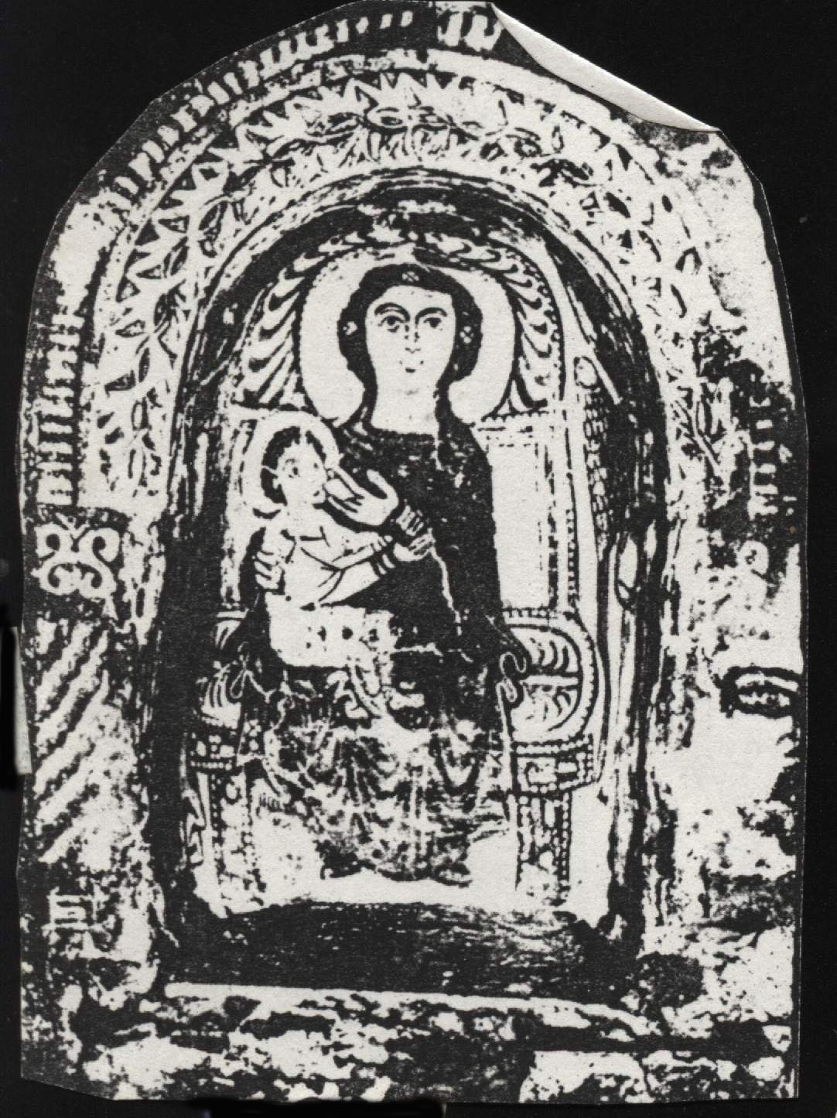

4. Expression of the strength of spirit

5. Having an attitude of prayer
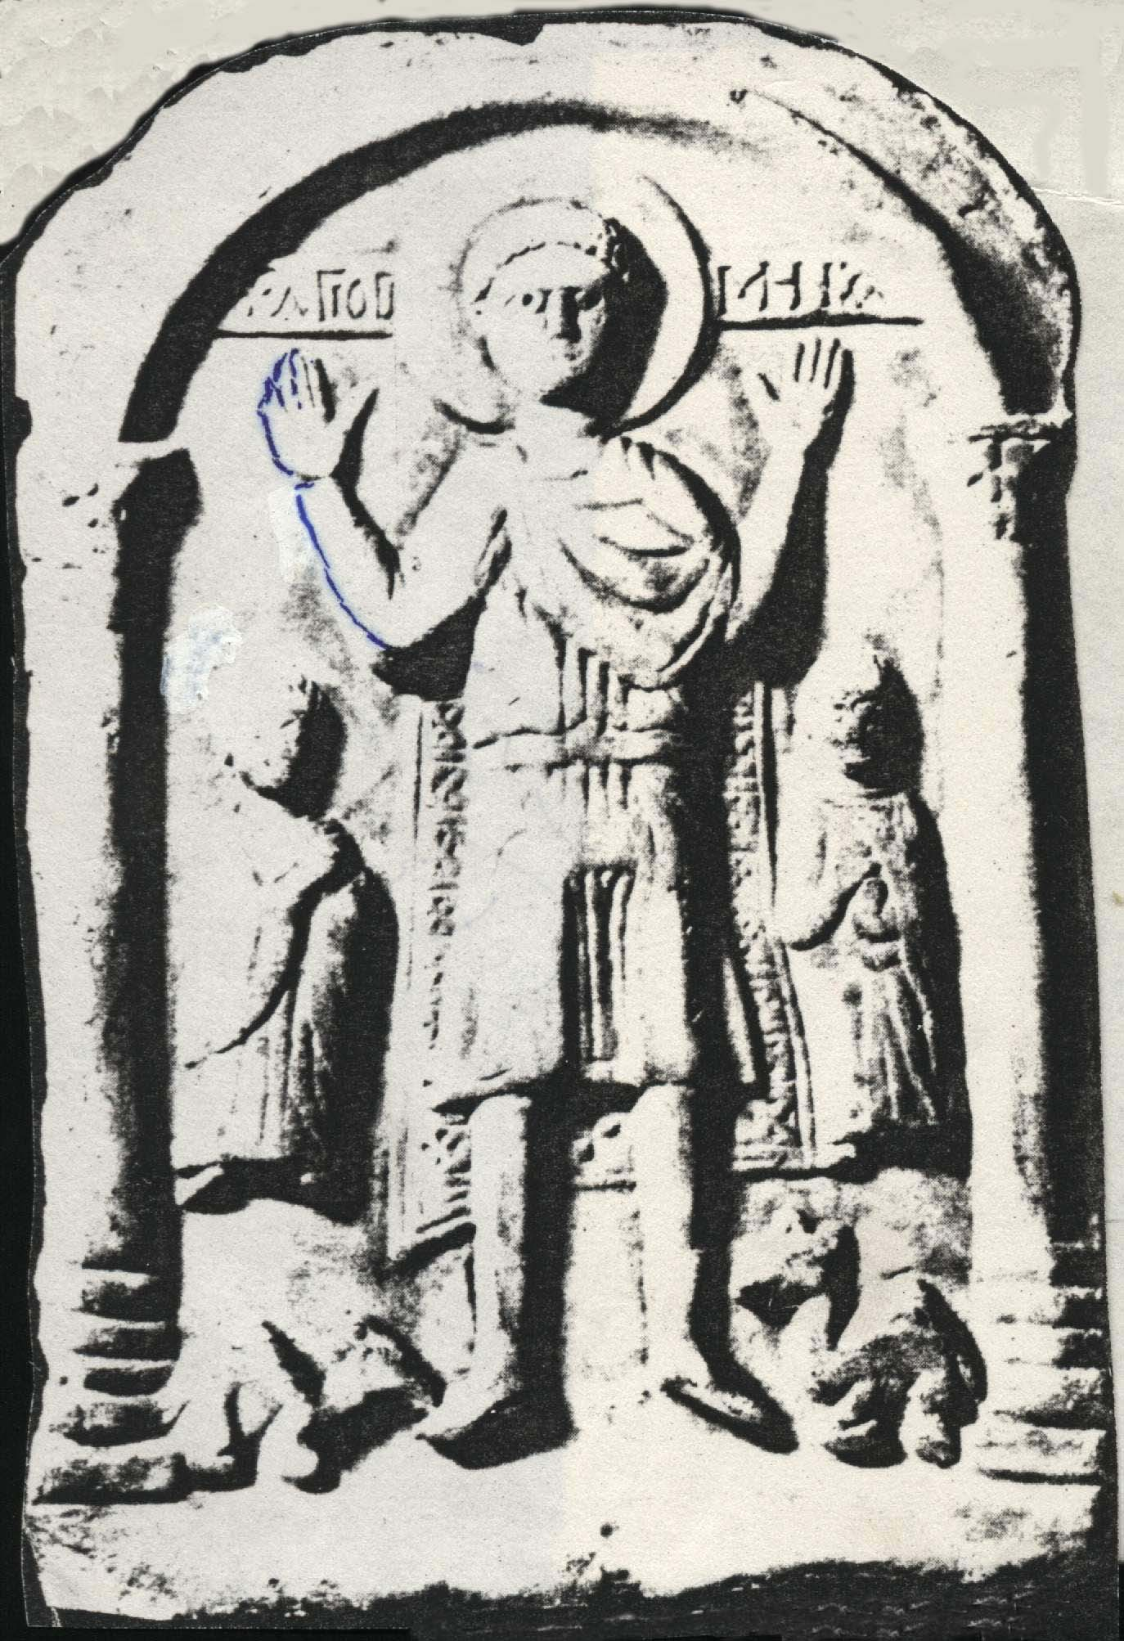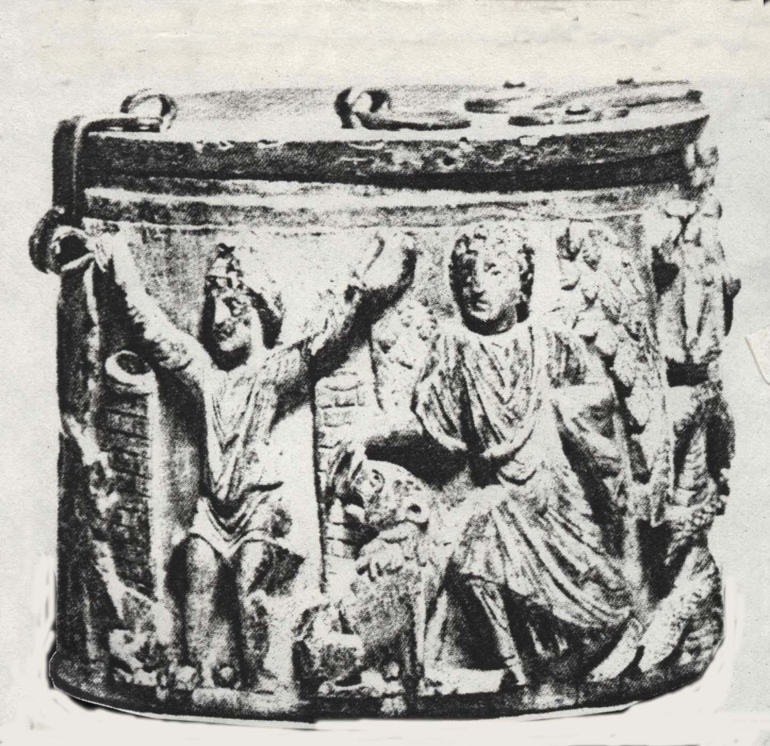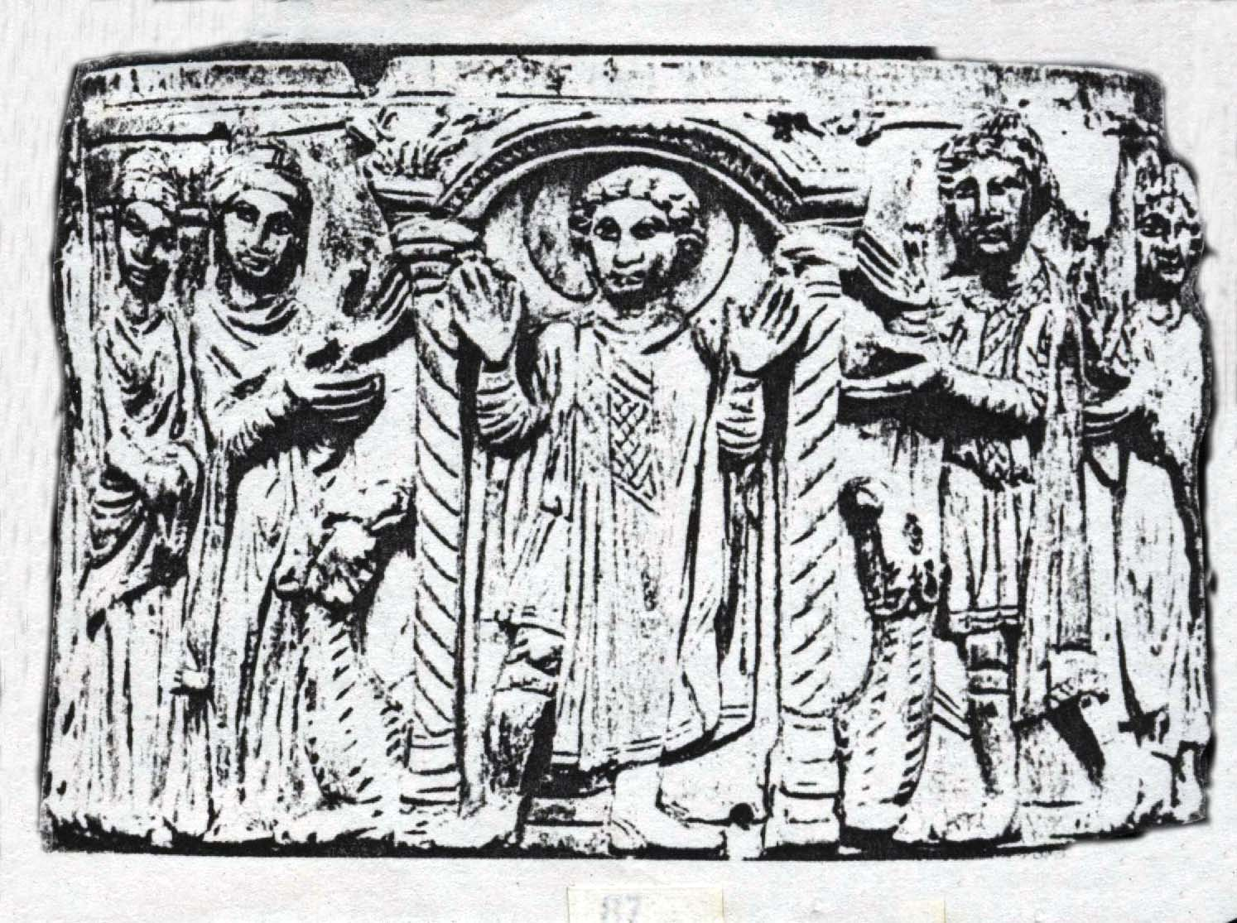

6. Bearing the cross

7. The lord’s providence

8. The inner sight

9. The military saints
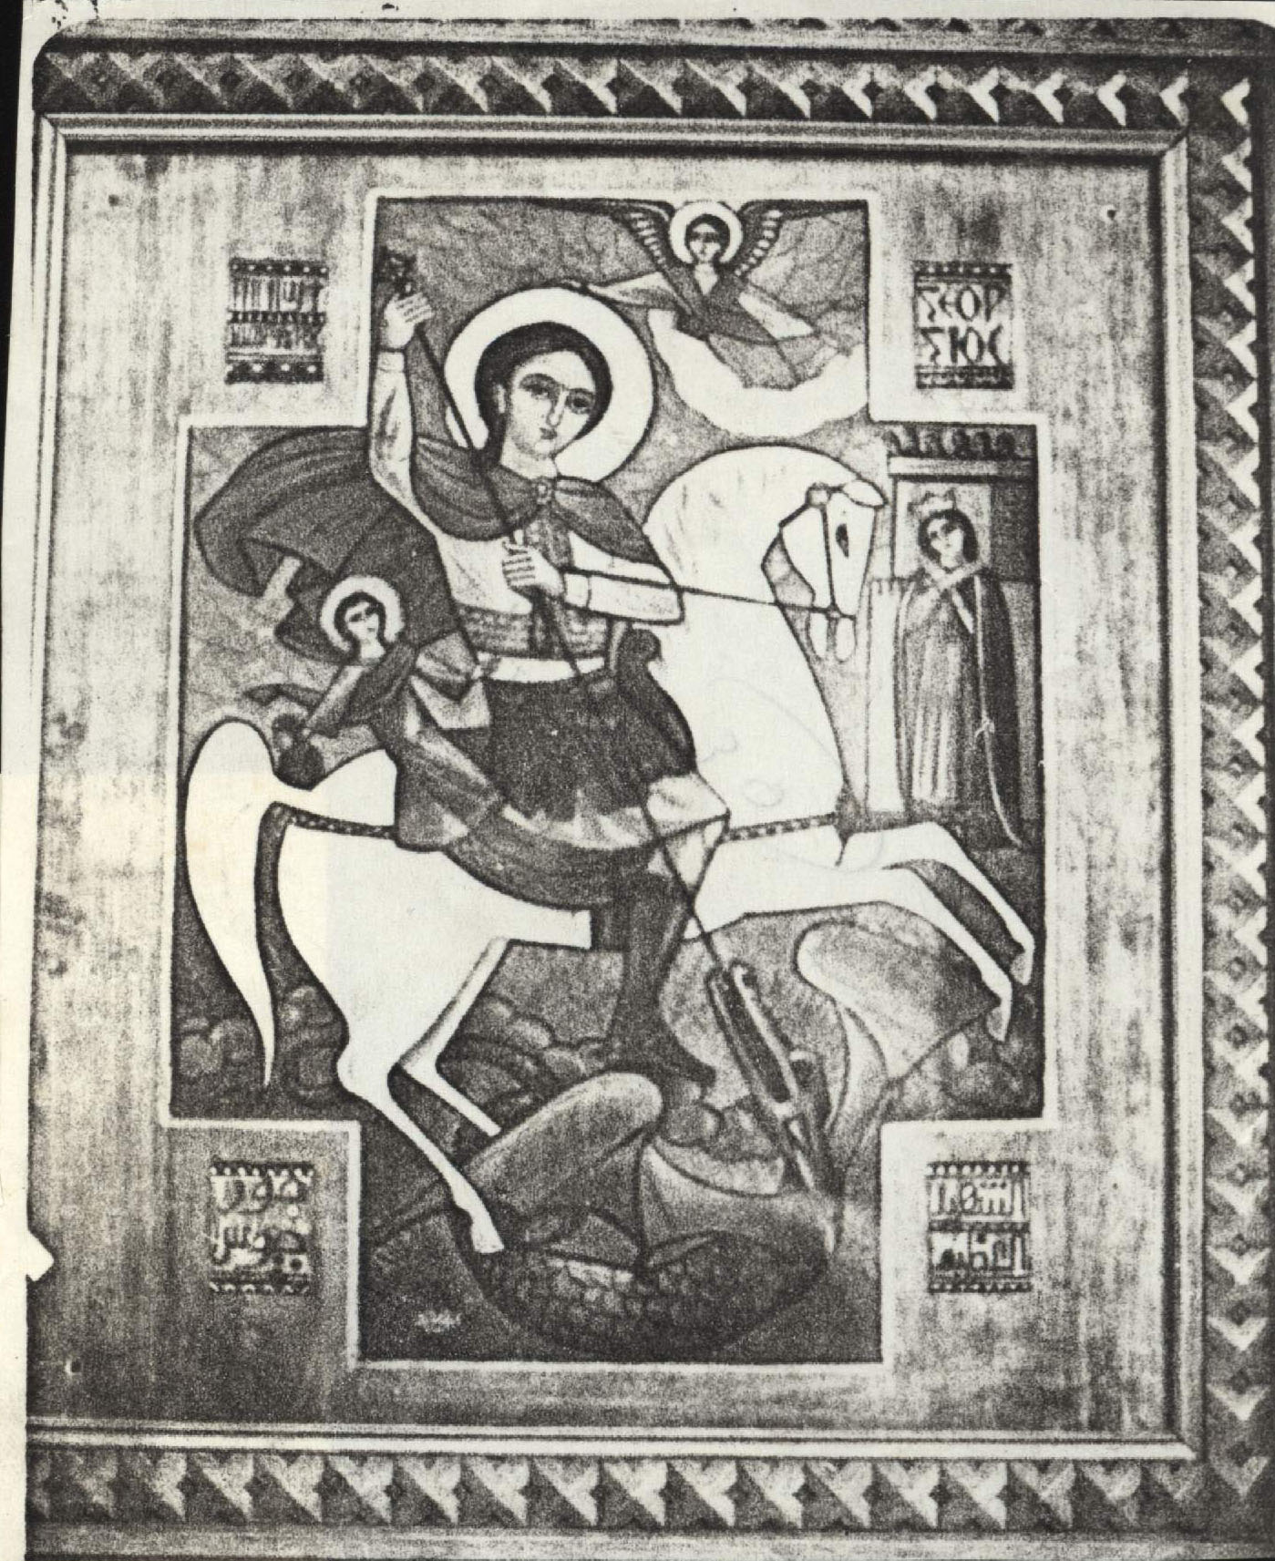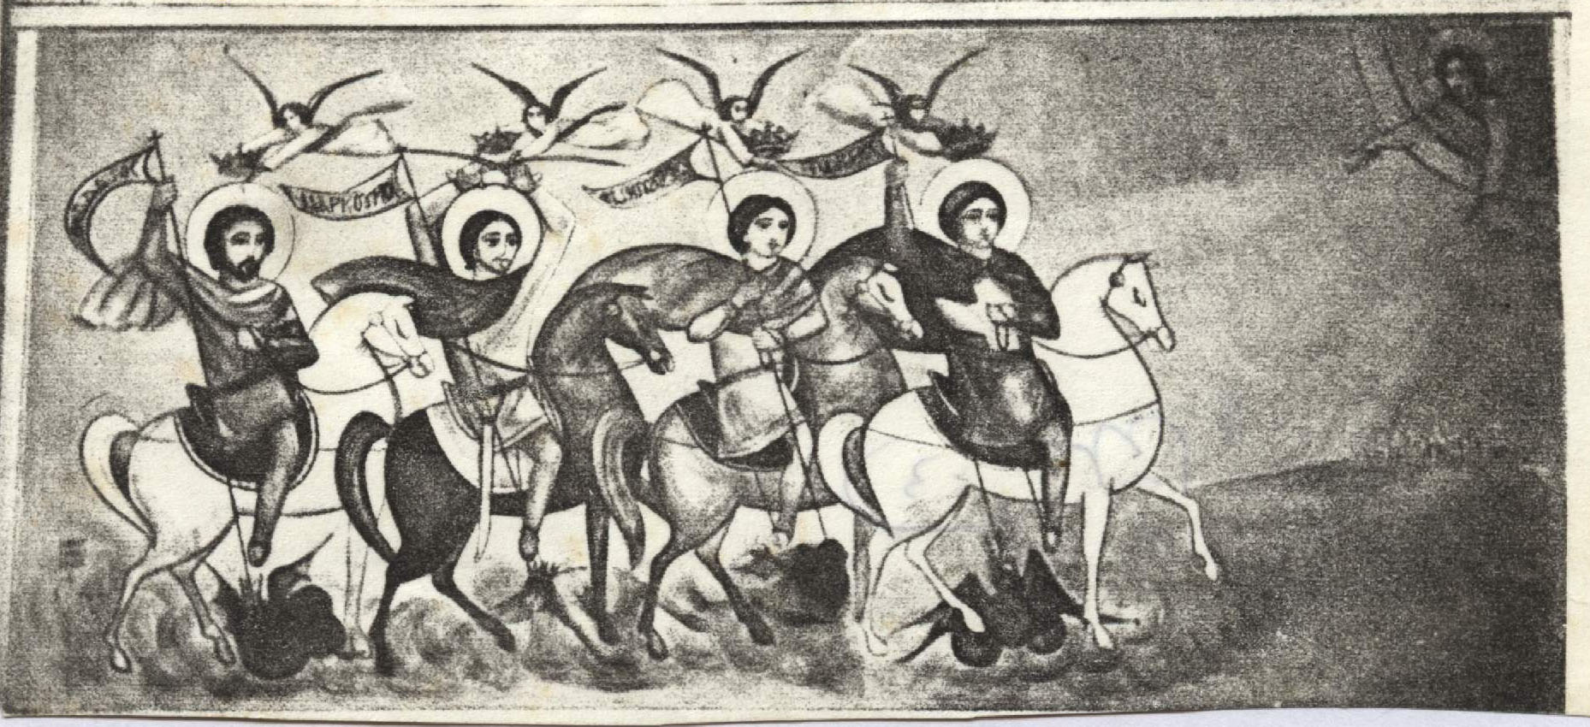

COPTIC ART AND ITS INFLUENCE THROUGHOUT THE WORLD
In the first centuries Egypt attracted many church leaders from the East and the West, to study the Holy Bible and theology in the School of Alexandria. They also practiced the angelic life in her deserts. Alexandrian teachers and monks preached into many countries. Through this openness of the Alexandrian Church, Coptic and Pharaonic arts spread indirectly throughout the whole world.
1. Naturally Coptic art had its effect on the arts of Ethiopia, Libya, Nubia, and the Sudan and so on, as the bishops of these countries following the Alexandrian See.
2. A resemblance has been observed between Celtic design and Coptic decoration motifs. A possible explanation of this resemblance might be found in the contact between the monks from Egypt and those from Ireland, for seven Egyptian monks preached in Ireland, and they were buried at “Desert Ulidh.”
Wessel states that “Coptic influence penetrated into the Irish art, and then went over once again into the developing German art. The Irish Church provided its wandering monks, and zealous missionaries, not only with the joyful tidings but also with the artistic spirit of the native church. Everywhere they settled, these Irish envoys employed themselves in spreading their art, and with it, indirect influences...”
3. The Coptic art had its influence throughout the whole Roman Empire and extended outside the empire, through the Coptic textiles.
4. Smith states that the icon of Christ the Triumphant, or the representation of Christ trampling underfoot the lion, the dragon, the asp and the basilisk, is known in Early France art as quoted from Egypt. The same portrait in the catacombs of Alexandria was quoted from the Ancient Egyptian art (Horus conquering the Reptiles). Smith says, “This transmission of Egyptian types into Early France art is neither surprising nor peculiar to this particular scene. In the first place it was natural, about the Eastern influence which entered Province through Marseilles and spread through Gaul in Carolingian time....”
Rkywart also says, “The contribution of Alexandria to the general development of church architecture is very difficult to estimate; Alexandrian churches unlike those of Constantinople were not simply altered by the modern invaders to suit their use but were mostly destroyed or rendered unrecognizable. We know much more about the Alexandrian element in Christian art, particularly the Alexandrian contribution to the course of Western painting... we also know that the miniature and landscape painters of Alexandria had far-reaching effects on the imperial ateliers in Constantinople.”

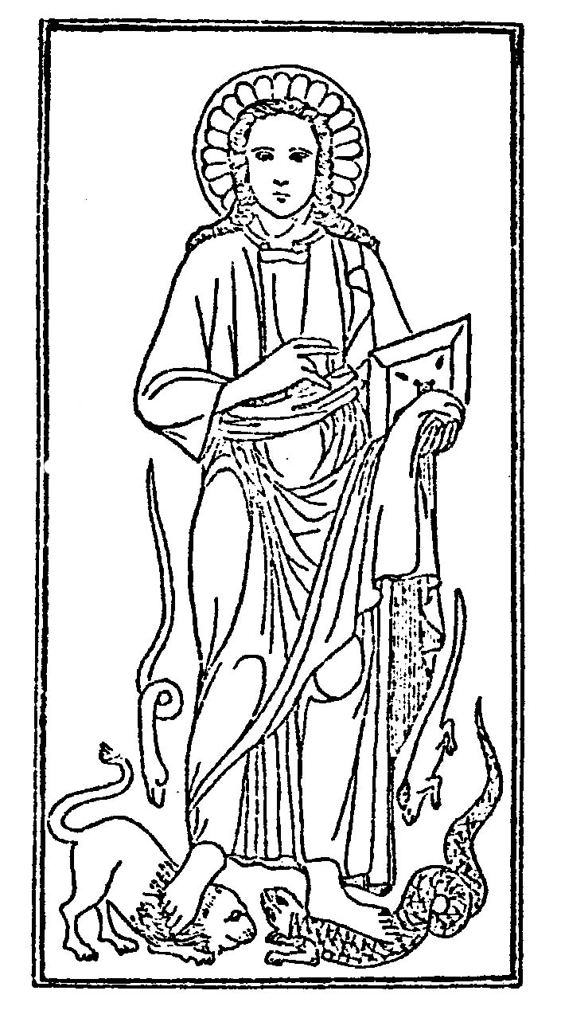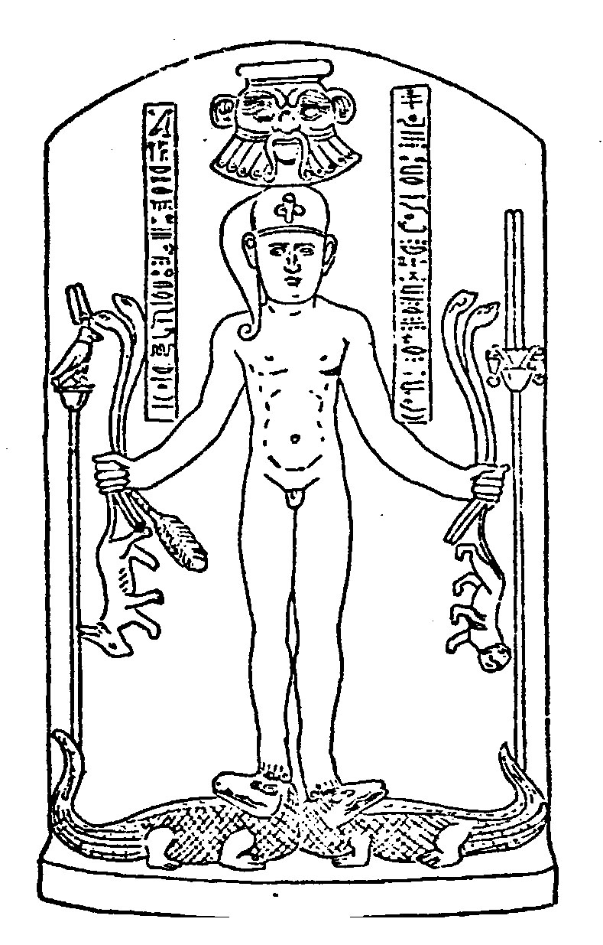

The Author: The School of Alexandria, Book 1, 1995,p. 17.
The Author: Introduction to the Coptic Orthodox Church, Ottawa Canada 1998, chapter 10.
For more details about the Coptic architecture and icons see my book "Church, the House of God".
The Author: Church House of God, sixth edition, Alexandria, p. 158 ff.
Strzygowski : Koptische Kunst XXIV.
Atia: History of Eastern Christianity.
Brooklyn Museum: Pagan & Christian Egypt, p. 10.
K. Wessel: The Coptic Art, p. 160,161.
Hamilton J.H.: Byzantine Architecture and Decoration, London 1933, p. 80-1.
H. Gwatkin: Early Church History, London 1909, vol. 2, p.155.
Quasten: Patrology, vol. 2, p.1.
Lebreton J.: Hist. of the Primitive Church, London 1949, vol. 3, p.731.
cf. Fr. Tadros Y. Malaty: The Early Fathers of the School of Alexandria. p. 72-6. (in Arabic).
Henry Chadwick: The Early Church, 1969, p. 96.
Quasten: Patrology, vol. 2.
Nelson : A New Catholic Comm. on the Holy Scripture, 1969, p. 15.
Pierre de Bourguet: Coptic Art, 1971. P. 61.
Brooklyn Museum, p. 6.
Wessel, p.72.
Coptic Church (Cairo): St. Mark, p. 145.
Ibid.
H. Read: Meaning of Art, 1956, p. 68.
The Art of Egypt through Ages, by various writers, London, the Studio, p. 193.
St. Mark, p. 146.
Brooklyn Museum, p. 10.
Dr. Waheeb A. Girgis (Bishop Gregorius): Christological Teaching of the Non – Chalcedonian Churches. Fr. Tadros Y. Malaty: Christology according to the Non-Chaledonian Churches. Fr. Tadros Y. Malaty: Physis and Hypostasis in the Early Church.
Coptologia, Volume 9, 1988, p. 111 ff. (Otto Meinardus: Pharaonism in Neo-Coptic Iconography)
For more details See: The Author: Church House of God, sixth edition, Alexandria, p. 164 ff.
Cawthra Mulock: The Icon Of Yuhanne & Ibrahim The Scribe, London 1946, p. 12.
Wessel, p. 232, 233.
Smith: Early Christian Iconography, p 146-150.
Rykwart: Church Building, p. 63.

